After evaluating multiple models - Logistic Regression, Random Forest, and SVM - the Random Forest model is recommended for this problem.

Best overall performance
- Random Forest achieved the highest scores across key metrics such as Accuracy, F1-score, and ROC-AUC, indicating strong predictive capability.
- Handles non-linear relationships
- Healthcare data often contains complex interactions between features. Random Forest effectively captures these non-linear patterns, unlike Logistic Regression.
- Robust to feature issues
- It is less sensitive to Multicollinearity, Outliers and Feature scaling
- Better generalization: Due to ensemble learning, it reduces overfitting and performs well on unseen data.

Below are the plots for Random Forest:
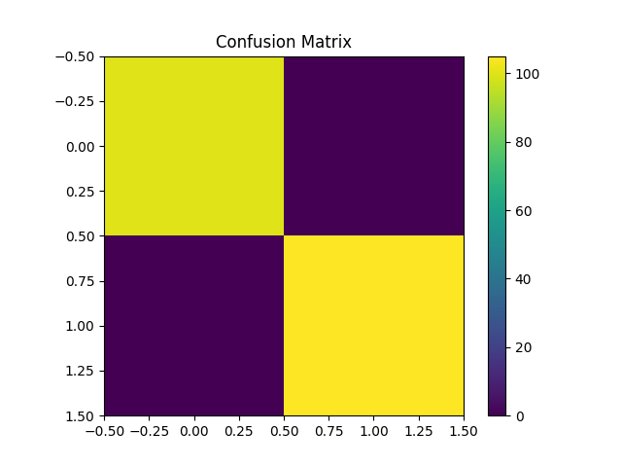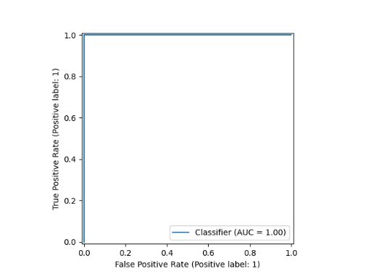
Below are the plots for Logistic Regression:

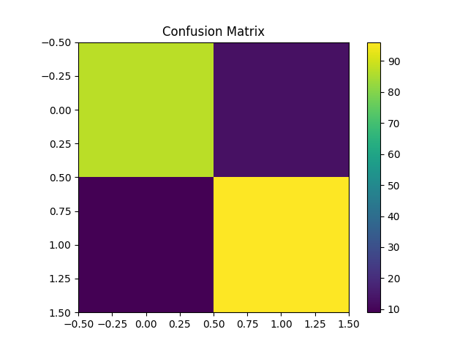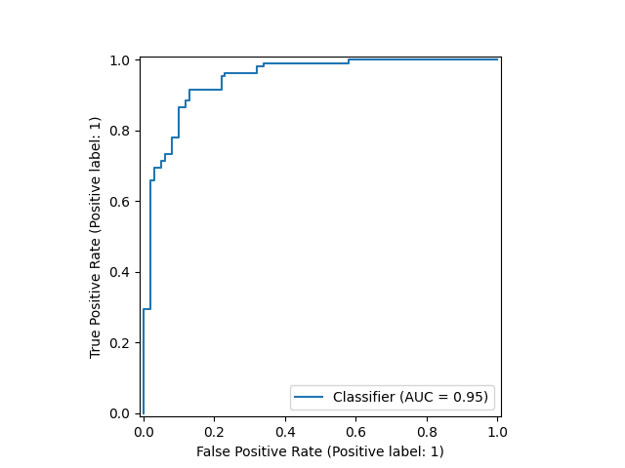

Below are the plots for SVM:

